# **GUI-Based Analysis of Frequency Response and System Stability**

## Clients

Mapua University, Self Made Project for Electronics Laboratory

## Objective / Goals / Purpose

To create a GUI using MATLAB’s Graphical User Interface Development Environment (GUIDE) to:

* Define and describe the concept of frequency response, including its role as the steady-state or forced response of a system.
* Exhibit the various methods for evaluating stability, including the use of pole-zero maps, Nyquist plots, and Bode plots.
* Present the benefits of using a Graphical User Interface (GUI) for interacting with and analyzing system responses.
* Describe the development and capabilities of a MATLAB-based GUI for visualizing step responses, Nyquist plots, and Bode plots, and for calculating key parameters like gain margin and phase margin.

## Technologies Used

MATLAB GUIDE, C/C++

## Description

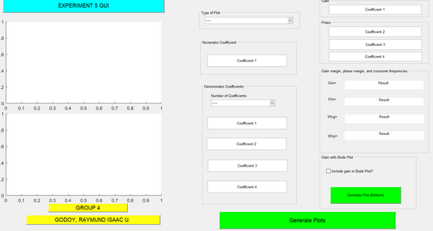

The project involves the development of a GUI in the MATLAB environments that visualizes the step response, Nyquist Plot, and Bode Plot of a closed-loop feedback system. It allows the user to determine what type of plot is to be used and extracts the coefficients for the created equations. In addition the GUI will calculate other parameters of the Bode plot which are the gain margin (Gm), phase margin (Pm), gain-margin frequency (Wcg) and phase-margin frequency (Wcp). The GUI will also employ an option of whether to add the measured Gm and produce another Bode plot with the gain added to the system.